**Group 3 Large Animal Surgery, surgeons**

**School of Veterinary Medicine**

**Faculty of Medical Sciences**

**Eric Williams Medical Sciences Complex**

**Uriah Butler Highway, Champ Fleurs**

**Trinidad, West Indies**

**E-Mail:vet.sch@sta.uwi.edu**

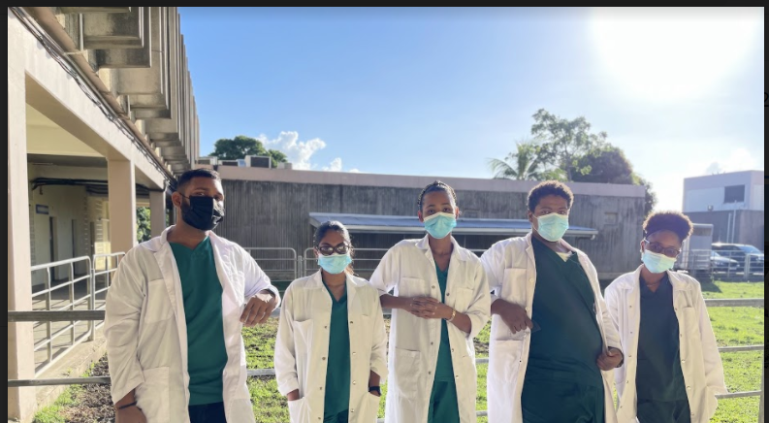***Travis Padarath Mellissa Lutchman Kishana Murray Adisa Moore Angel Neptune***

**Veterinary Consent Form**

Owner’s name _________________________________________________________

Address ___________________________________________________________________

Contact: Home _____________________________ Work phone: _____________________

Emergency phone: ____________________________________________________________

Animal Id number: __________________________________ Breed _________________________

Diet ___________________________________________________________________________

Medical history ___________________________________________________________________

Current medication/ dosage __________________________________________________________

I am the owner / agent of this ______________________________and I have the right and authority to grant consent.

I authorize the ____________ veterinary facility, student and staff to perform the procedure and treatment, along with the expected outcome and risk involved.

Procedure: ______**1) Foreign body removal** ___________________________________________

_______________**2) Intestinal resection and Anastomosis** _______________________________________________

________________**3) Rectal Prolapse repair**___________________________________________________________

I understand that there is risk to anesthesia, surgical and the health of the animal, however any procedure that requires general or regional anesthetic I consent to their use as it is needed.

I have read and understood this consent form. I consent to the proposed procedures.

Signature / Agent :_________________________________ Date ____________________