DRUG TABLE FOR LARGE ANIMAL SURGERY
Drug | Use | Concentration (mg/ml) | Dose (mg/kg) | Toxic dose | Injection site | Calculation  (dose (mg/kg) x weight (kg))  ÷ conc. (mg/ml) | Withdrawal Time
Xylazine | Sedative | 20mg/ml | 0.05mg/kg | - | IM | (0.05mg/kg x 45 kg) ÷ 20mg/ml = 0.12 mls | Slaughter: 5 days  Milk – 4 days
Ketamine | Sedative | 100mg/ml | 0.1 mg/kg | - | IM/IV | (0.1 mg/kg x 45 kg) ÷ 100mg/ml =0.045 ml | Slaughter- 3 days  Milk- 48 hours
Lidocaine | Local anaesthetic | 20mg/ml | 5 mg/kg | 10mg/kg | IM | (5 mg/kg x 45kg) ÷ 20mg/ml = 11.3ml | Slaughter – 5 days  Milk – 96 hours
Flunixin meglumine | Analgesia | 50mg/ml | 1.1mg/kg | - | IV | (1.1mg/kg x 45kg) ÷ 50mg/ml = 1.0mls | Slaughter 7 days  Milk- 36 hours
Pen Strep | Antibiotic | 200,000UI/mL | 20,000UI/Kg | - | SC  IM | (20,000UI/kg x 45kg)  ÷ 200,000UI/mL = 4.5 mls | Slaughter- 30 days  Milk- 10 days
Tetanus Antitoxin | Reduce risk of tetany in small ruminants | 1500UI/5ml | 1 single dose (5mls) | - | SQ | 1 dose | Slaughter- 21 days
Sheep/Goat weight estimated to be 45 kgs

EMERGENCY DRUGS
Drug | Indication | Concentration | Dose (mg/kg) | Route of Administration | Calculations  (dose (mg/kg) x weight (kg)÷ conc. (mg/ml)
Tolazoline | Xylazine reversal drug | 100 mg/ml | 0.1mg/kg | IV | 2-4 times the Xylazine dose  (0.1 mg/kg x 45kg) ÷ 100mg/ml = 0.045mls
Epinephrine | Anaphylaxis | 1mg/ml | 0.02 mg/kg | IV | (0.02 mg/kg x 45 kg) ÷ 1mg/ml = 1.0mls
Atropine | Bradycardia | 1% or 10mg/ml | 0.2mg/ml | IM  SC | (0.2mg/kg x 45kg) ÷ 10mg/ml = 1.0mls

In cases of General Anesthesia, Constant rate Infusion can be used.
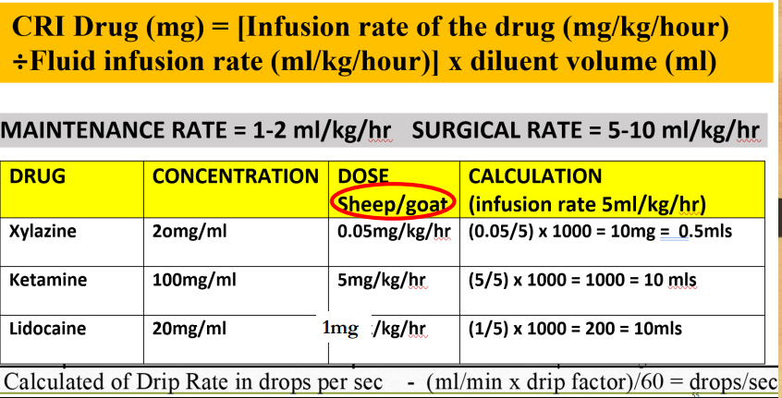
For the sheep/goat 45kgs
(45kg x 5ml/kg/hr x 20 drops/ml) = 1.25 drops/second
60 (min/hr) x 60 (sec/min)

