Palmar Digital Neurectomy Procedure

1)Under local analgesia, the neurectomy can be performed while the animal or horse is standing.
2)The local analgesia should be injected at the level of the abaxial surface of the sesamoid bones over the palmar nerves.
3)The nerves can be felt or palpated in this region.
4)Infiltration of the site avoids trauma or irritation.
5)A neurectomy should be performed 10 days after the palmar nerve block is done, to reduce inflammation in that area.
6) General anesthesia can also be utilized, especially for epineural capping.
7)The region of interest is clipped, shaved, and prepared for surgery.
8)To exclude the hoof that is a source of contamination, utilize plastic adhesive drapes.
9)The approach to the nerve is the same when conducting both techniques that are the simple guillotine method and the epineural capping.

10) For the simple guillotine technique, over the dorsal border of the flexor tendons, a 2cm long incision is made.
11)The incision could be 3-4cm long which is continued through the subcutaneous tissue, once the epineural capping is being performed.
12)Minimal trauma should be inflicted on the tissues.
13)Making an incision over the dorsal border of the flexor tendons enables the individual operating to come close to the palmar digital nerve.
14)The relationship of the artery, nerve, vein, and ligament of the ergot running together, allows the surgeon to orient themselves.
15) The surgeon will search for the accessory branches of the palmar digital nerve that are found in close proximity to the ligament of the ergot.
16)A 2cm portion of the accessory branch is removed with a scalpel.

17)Using the guillotine technique the nerve is identified, then dissected free from the subcutaneous tissue.
18)Nerve can be identified by stretching it since it puckers, the scraped surface reveals longitudinal axon strands and a small incision exposes the cut transverse sections of nerve bundles.
19)Once identified, the distal extremity of the nerve is severed at the incision site.
20)A hemostat is clipped to the nerve stretching it out, meanwhile, a scalpel or CO2 laser is used to cut at the proximal limit of the incision.
21)The nerves spring up into the tissue planes and disappear while the nerve endings are sealed by the CO2 laser that reduces the possibility of painful neuromas.
22)Nonabsorbable suture material is used to close the skin with interrupted sutures.

23)An technique that could be done is the pull-through technique which is an extension of the guillotine technique.
24)The procedure is similar to the guillotine technique, however instead of transecting the nerve at the proximal incision end, traction is placed on the distal nerve, and at the base of the proximal sesamoid bone, the second incision of 1cm is made over the nerve.
25)Then the digital nerve is pulled out from the proximal incision followed by the guillotine technique to transect the nerve.
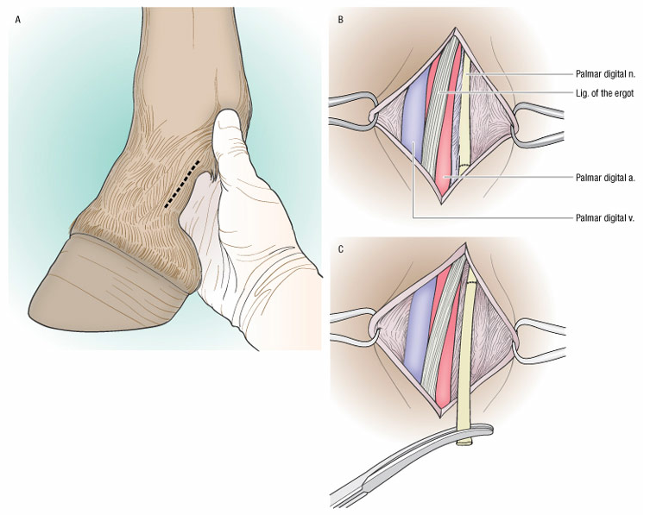
Turner’s and McIlwraith’s
Techniques in Large Animal Surgery
4th Edition Book
Dean A Hendrickson

