**Udder Amputation (Mastectomy)**

Indication: In treatment of chronic or gangrenous mastitis, tumours, injuries and suspensory ligament breakdown.

The udder of small ruminants have two teats whilst cows have four teats.

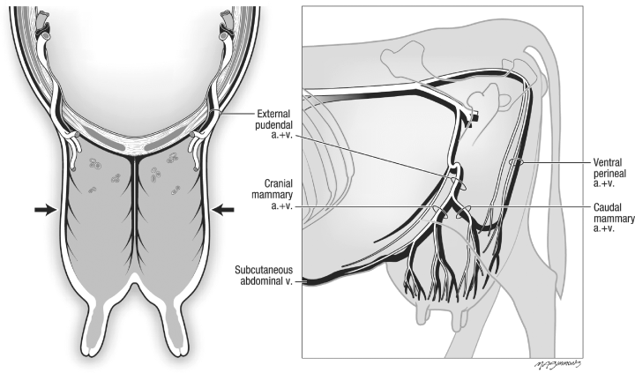

Local blocks:

An epidural or pudendal block might be helpful but may not be easy to perform.

Position/preparation:

Dorsal recumbency with legs positioned in a way not blocking access to the udder, under general anesthesia. This provides better accessibility to the patient. The mammary gland should be cleansed and isolated from the rest of the animal with the use of drapes.

Surgery Supplies:

Standard surgery pack

0 and 2-0 absorbable suture for ligatures

0 suture for skin (cutting needle)

stents for mattress sutures

stent for seroma management (optional)

Assistant to manipulate the udder (optional)

Surgical procedure

* An elliptical incision is a made through the skin, midway up the udder and oriented along the long axis of the patient. It is imperative to save as much skin as possible for the purpose of primary closure can be achieved with minimum tension.
* The skin is dissected off the udder down to the inguinal area.
* For very large udders, the initial incision should be reflected down by the base of the udder as the dissection is continued.
* Using careful blunt dissection, the udder is lifted off the body wall. Dissection from the cranial aspect of the udder first is preferred as it is easier to separate from the abdominal wall. Vessels are double ligated as identified.
* The main vessels that require ligation are the external pudendal artery and vein, smaller mammary branch of the ventral perineal artery and caudal superficial epigastric vein.
* After ligating blood vessels the median suspensory ligament is cut near the body wall. Ideally, about 1-2cm of the medial suspensory should remain on the body, as it gives a place to anchor the skin and help obliterate dead space during closure.
* Once the udder is removed, the skin is closed if possible. Mattress sutures with stents may be necessary and drainage holes or drains should be included. Tension- relieving sutures such as near-far-far-near can be placed at intervals to appose the deeper tissues with interrupted sutures in between to bring the remainder of the fascia and subcutaneous tissues into apposition. The use of a penrose drain to allow fluids to drain away from the healing incision.
* If closure isn’t possible, the deeper tissues are tacked to the body wall and the wound left open.
* A rolled towel can be sutured to the wound to apply pressure and minimize seroma formation.

Postoperative care:

Stall rest; minimal exercise

NSAIDs for 3 days

Suture removal in 10-14 day

Complications:

* Dehiscence is relatively common but is a minor issue.
* Blood loss as the mammary gland is highly vascularized
* Surgical site infection