**CLASSIFICATION OF TEAT LACERATIONS**

Teat lacerations are commonly caused by external trauma from varying sources, being the patient’s own hind limb, neighboring cows, cuts and abrasions from sharp objects such as wires.

Animals with poor udder conformation such as low hanging teats are predisposed to teat lacerations.

Goats have a higher incidence of teat injuries than cows due to their pendulous udders and large teats.

Lacerations that do not penetrate the mucosa of the teat and does not affect milking generally heal rapidly by secondary intention with the aid of topical medication and bandaging.

Lacerations that penetrate the mucosa involving the teat cistern require suturing to maintain normal teat function for milking and to prevent development of teat fistula or acute mastitis.

Classification of Open Lacerations is based on:

* Duration from time of trauma: Lacerations that have occurred less than 12hrs are classified as acute and lacerations older than 12hrs are chronic. Lacerations have a better prognosis when treated within the first 12hrs. Fresh lacerations heal better than older lacerations.
* The localization and conformation of the laceration: Teat lacerations are classified as simple or complex (inverted ‘‘Y’’ or ‘‘U’’) longitudinal or transverse, and proximal or distal. The orientation of the blood supply of the teat is longitudinal. A transverse laceration results in more damage to the blood supply resulting in more edema, avascular necrosis, and dehiscence postoperatively compared with a longitudinal laceration. The more circumference is involved, the worse is the prognosis.

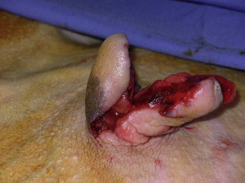 Picture showing complex teat laceration.

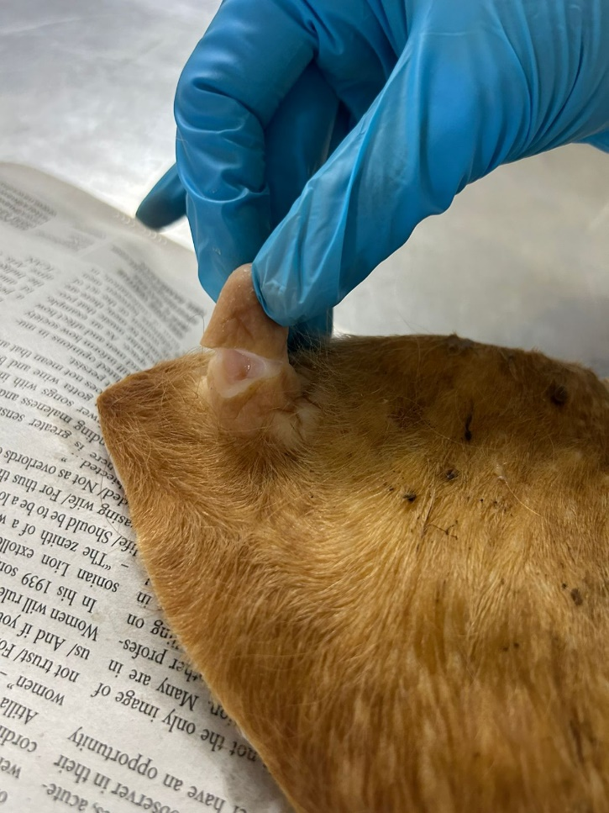 Picture showing transverse teat laceration.

* The thickness of the lesion: Teat lacerations are classified as being partial thickness (skin to submucosa) or full thickness (skin to mucosa with milk leaking out of the incision). Lacerations that just involve the body of the teat heal better than ones that involve the sphincter. With full-thickness lesions, the defense mechanisms of the teat against mastitis are bypassed, increasing the risk of clinical mastitis. Prompt surgical reconstruction of the injured tissue is needed to protect the quarter against environmental pathogens. In cases of incomplete lacerations (when the integrity of the teat cistern has not been compromised), surgical intervention may not be necessary.

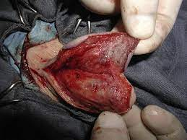 Picture showing superficial teat laceration.

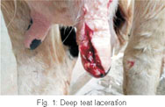

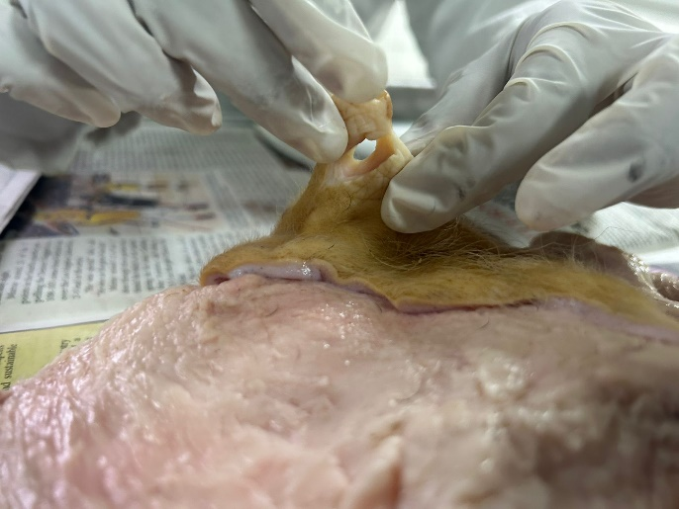Picture showing deep teat laceration.

**Different classifications have varying prognoses.**

Evaluating open teat lacerations:

* Presence of edema
* Degree of contamination
* Amount of tissue loss
* Direction of laceration
* Site of laceration