**TEAT AMPUTATION**



Indication: Excessive tissue loss, configuration of laceration (complex laceration) that causes irreplaceable damage to teat, gangrenous mastitis.

* Mastitis must be treated before amputation
* In case of chronic mastitis open amputation is done to provide permanent drainage
* Prophylactic intramammary injection of antimicrobials and milk drainage is performed immediately before amputation.

Disadvantages:

* Permanent
* The amputated quarter is no longer viable for milk production, half in goats.

Patient restrain and preparation:

* Can be done with the patient standing and properly restrained
* Tail tie can be done
* The teat and udder is shaved and cleansed/
* Teat anesthesia is performed.

Surgical Equipment:

* Teat clamp
* Scalpel handle and blade
* Suture material (4-0, 3-0)
* Emasculator (for closed amputation)

Techniques (Open & Close) :  
Open

* Once damage does not involve the base of the teat, the teat clamp is applied at the level of annular ring.
* Making an elliptical incision in the sagittal plane around the teat junction of the proximal and middle thirds.
* The teat wall is sharply dissected in a slightly proximal direction and transected, thus creating a fish mouth-like teat stump.
* Bleeding blood vessels are ligated separately.
* The skin is closed with interrupted sutures accordingly.
* If the laceration does involve the teat base, amputation is performed just distal to the annular ring. A skin flap attached to the base must be preserved.
* The wound is curetted and rinsed, margins debrided and submucosa and intermediate layers sutured.
* The skin flap is used to cover defect and closed with interrupted sutures.

Close

* Teat clamp is applied at the level of the annular ring, unless the damage involves the base of the teat.
* The emasculator is applied and make an elliptical incision distal to the annular ring.
* The teat is removed and closure of the layers are done as in open amputation.

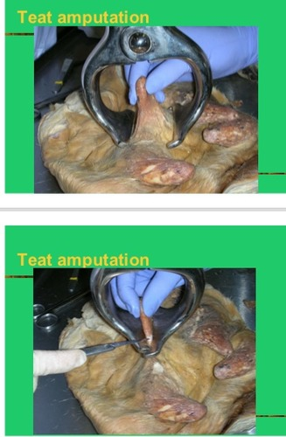

If the corresponding mammary gland did not have mastits before surgery prognosis is favorable. The quarter will secrete milk until pressure atrophy of the alveolar tissue occurs and dries up the quarter.

The remaining quarters/half will produce more than 75% of the previous milk yield due to blood flow bypassing the dried up quarter for the secreting quarters/half.

Complications:

* Mastitis
* Surgical site infection
* Myiasis

Aftercare:

* Analgesia for 4 days
* Antibiotics for 3 days
* Quarter lavaged twice daily with aseptic solution