**SUPERNUMERARY TEATS**

* A congenital condition therefore affected animals not recommended for breeding.
* May be found between the front and rear teats and/or attached to the udder behind the rear teats or to the base or the side of one of the main teat.
* They are shorter than normal teats and have thinner walls.
* Can have its own independent gland.
* Most frequently undetected until after calving and first milking.
* Can interfere with milking and prone to infection.

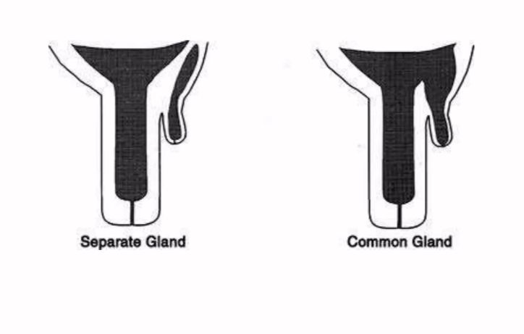

Diagnosis: ultrasonography, injection of dye.

Management:

Treatment is amputation of the accessory teats, when the animal is a young heifer, before the gland becomes active.

Normally removed with curved scissors early in life.

Supernumerary teat that are co-joined to a major teat needs to be repaired surgically than just snipped off. The repair should be performed when they are large enough to be manipulated. This is normally at age 3-6 months.

