**ANATOMY OF UDDER AND TEAT**

**Bovine:**

Median Suspensory Ligament

The most important support for the udder (MSL)

Clearly divides the udder into the right and left halves

The MSL is composed of elastic tissue that stretches to allow the udder to expand as it fills with milk.

The udder of a cow producing 40 lbs. of milk

in a 12-hour period can weigh up to 100 lbs.

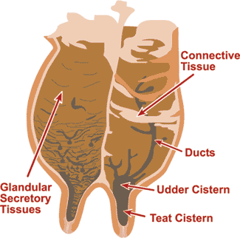

Lateral Suspensory Ligament

Chiefly fibrous and non-elastic (don't stretch).

The LSLs extend along both sides of the udder and at intervals send sheets of tissue into the gland to provide support to the inside contents of the udder

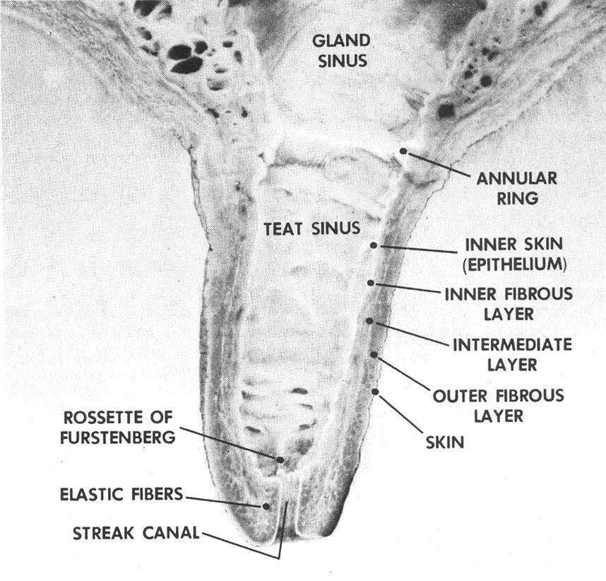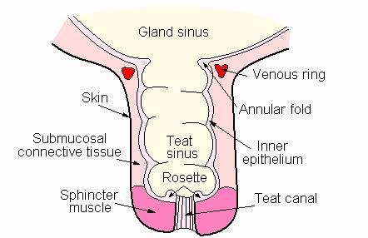

Streak canal:

width 0.4-0.7 mm

Length 8-12 mm

* TEAT SPHINCTER- MUST HAVE GOOD INTEGRITY, MILK SHOULDN’T BE LEAKED OUT WHEN THE ANIMAL ISNT BEING MILKED
  + PREDISPOSES ANIMAL TO INFECTION
  + MAKES IT DIFFICULT FOR SURGERY TO BE DONE
  + WHAT AFFECTS TEAT SPHINCTER INTEGRITY?
    - HIGH PRESSURE VACUUMS IN MILKING MACHINE
    - TRAUMA

A diagrammatic representation of the innervation of the bovine mammary gland.

Left lateral view of the bovine mammary gland showing the lymphatic drainage.

**Small Ruminant:**

