**TEAT PATHOLOGIES**

Teat Surgery- Procedures

* Teat cistern laceration repair.
* Emergency teat laceration repair.
* Polyp removal.
* Removal of calculi and lactoliths
* Stenosis of the teat orifice.
* Treatment of “spider teats”
* Atresia (imperforate teats).
* Partial Prolapse of the teat canal
* “Leaky teats.”
* Supernumerary teat removal.
* Chronic teat fistula repair.
* Amputation of the udder.

Relative importance of different teat conditions

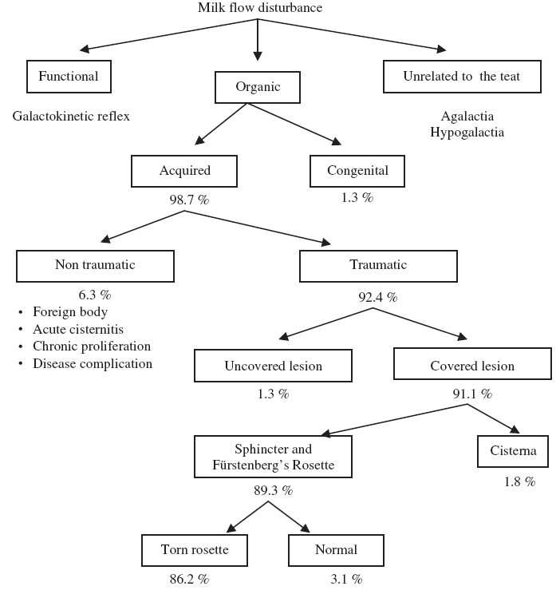

**Management of teat obstructions**

Danish Teat Splitter

* For opening teat orifices which are small
* Different types- Wisconsin
* 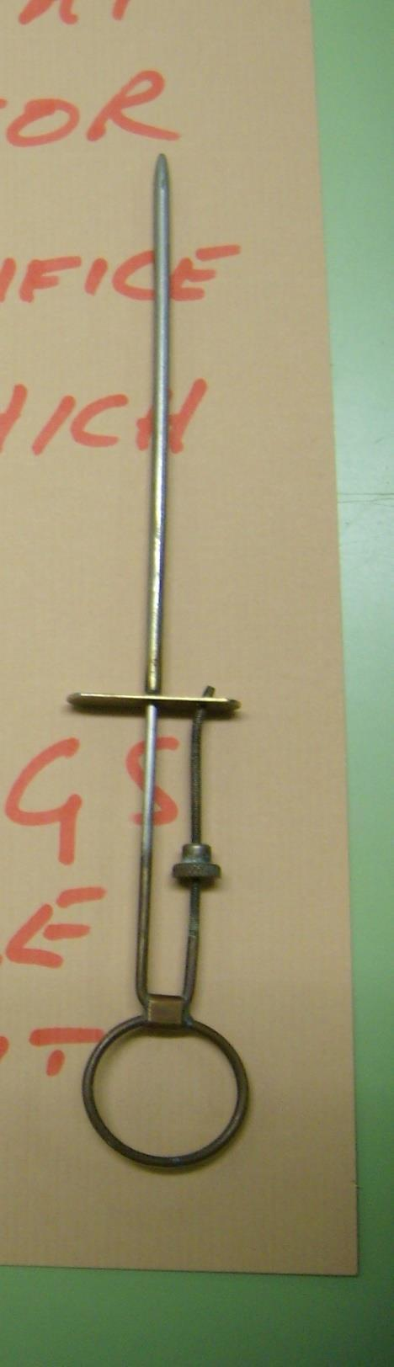
  + INSIDE THE GLAND MANIPULATE TO EXPRESS THE BLADES AND CUT FROM THE INSIDE OUT
    - CUT UNTIL YOU GET A SLOW DRIP OF MILK IN THE ANIMAL STANDING

Stricture of the teat orifice

* called “hardmilkers”
* usually due to trauma to teat end and scar formation
* use Lichty teat knife or bistoury to open teat orifice without cutting sphincter muscle

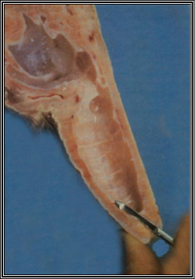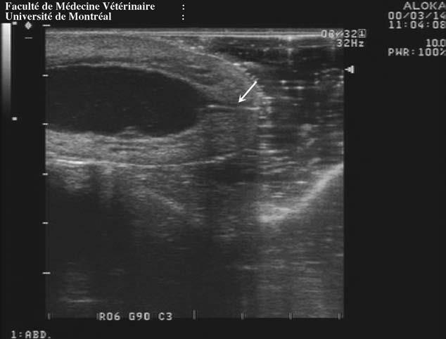

* IT’S BEST TO USE TEAT SPLITTER, TO AVOID CUTTING TEAT CANAL

Covered teat injuries

* These are defined as those that do not involve the skin (injury is located in the inner teat) and they represent 70-90% of all teat problems.
* Conservative Therapy poses fewer long-term complications than blind surgical resection
  + resting the teat for a total of 9 days

Treatment for Spider Teat

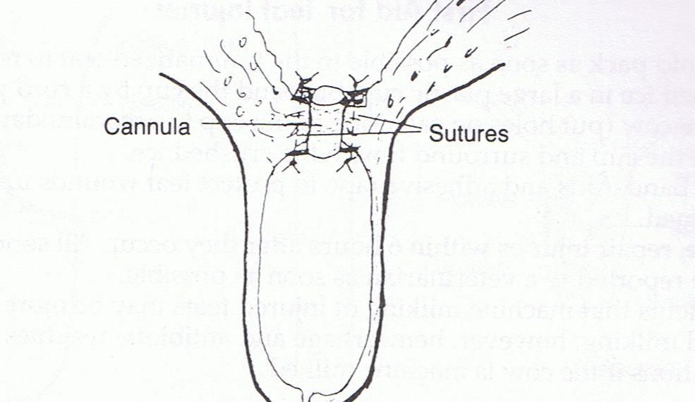

Teat peas

* teat peas may be tissue masses or hematomas
  + attached to the teat wall with a broad base
  + attached to the wall as a polyp
  + free floating
* milk stones or “lactoliths”

**Removal of Teat peas**

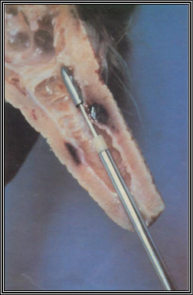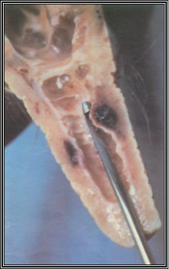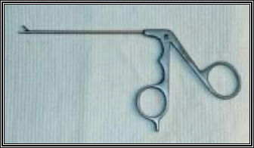

**Surgical correction of scar tissue obstructions in the teat**

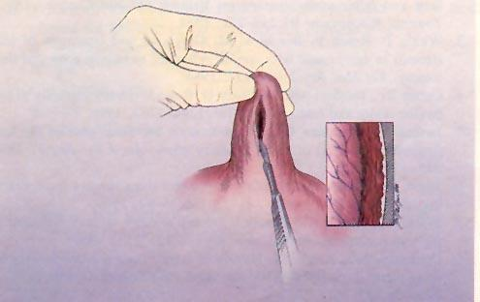

**Silastic implants**

